If you install git on your computer, you can now open the git bash terminal.

If you type python –version on the git bash terminal, you should see the following information:

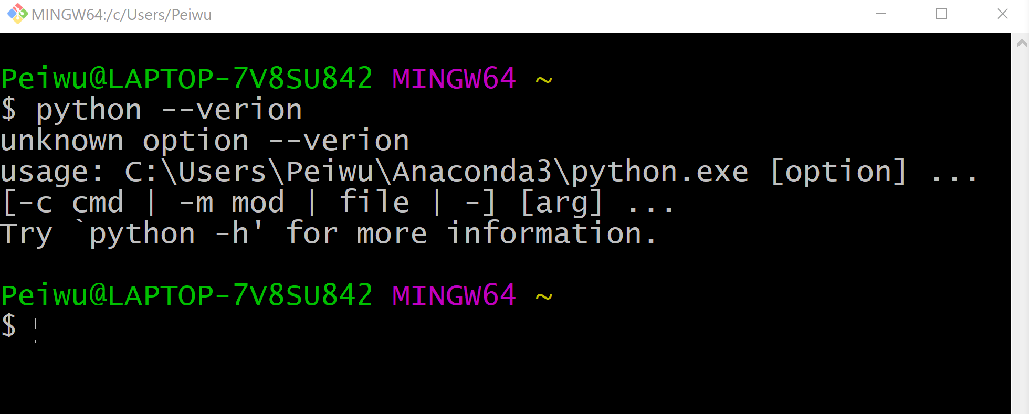

If not, that means you git bash can not talk to python.

Then you type the following command to set up your git account. The email should be the email you register Github.

Peiwu@LAPTOP-7V8SU842 MINGW64 ~

$ git config --global user.name "peiwu"

Peiwu@LAPTOP-7V8SU842 MINGW64 ~

$ git config --global user.email "qaydm1979@gmai.com"

Peiwu@LAPTOP-7V8SU842 MINGW64 ~

$ git config --global core.editor "Atom --wait"

Peiwu@LAPTOP-7V8SU842 MINGW64 ~

We choose Atom as our text editor.

If you type atom on the command line, you should be able to open atom text editor as the following.

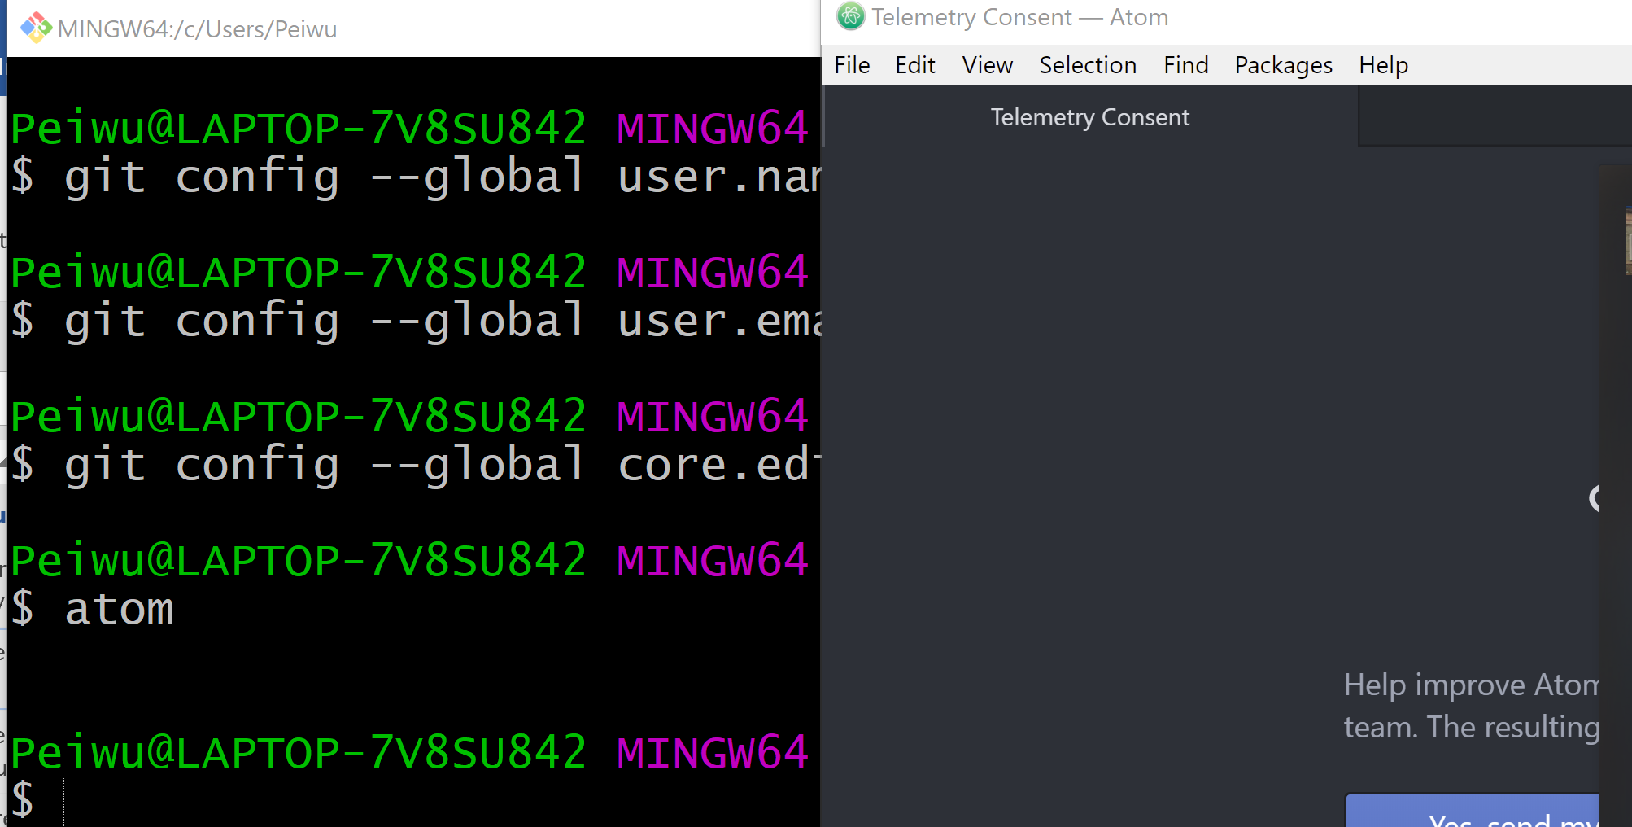

If not, that means you git bash can not talk to Atom.